1/4/2022

**Partitioned mash Weights**

* Weight proportions (from each individual snps in the posterior step) similar, but not exactly the same as the mixture proportions mash generates (from average of 100 trials)

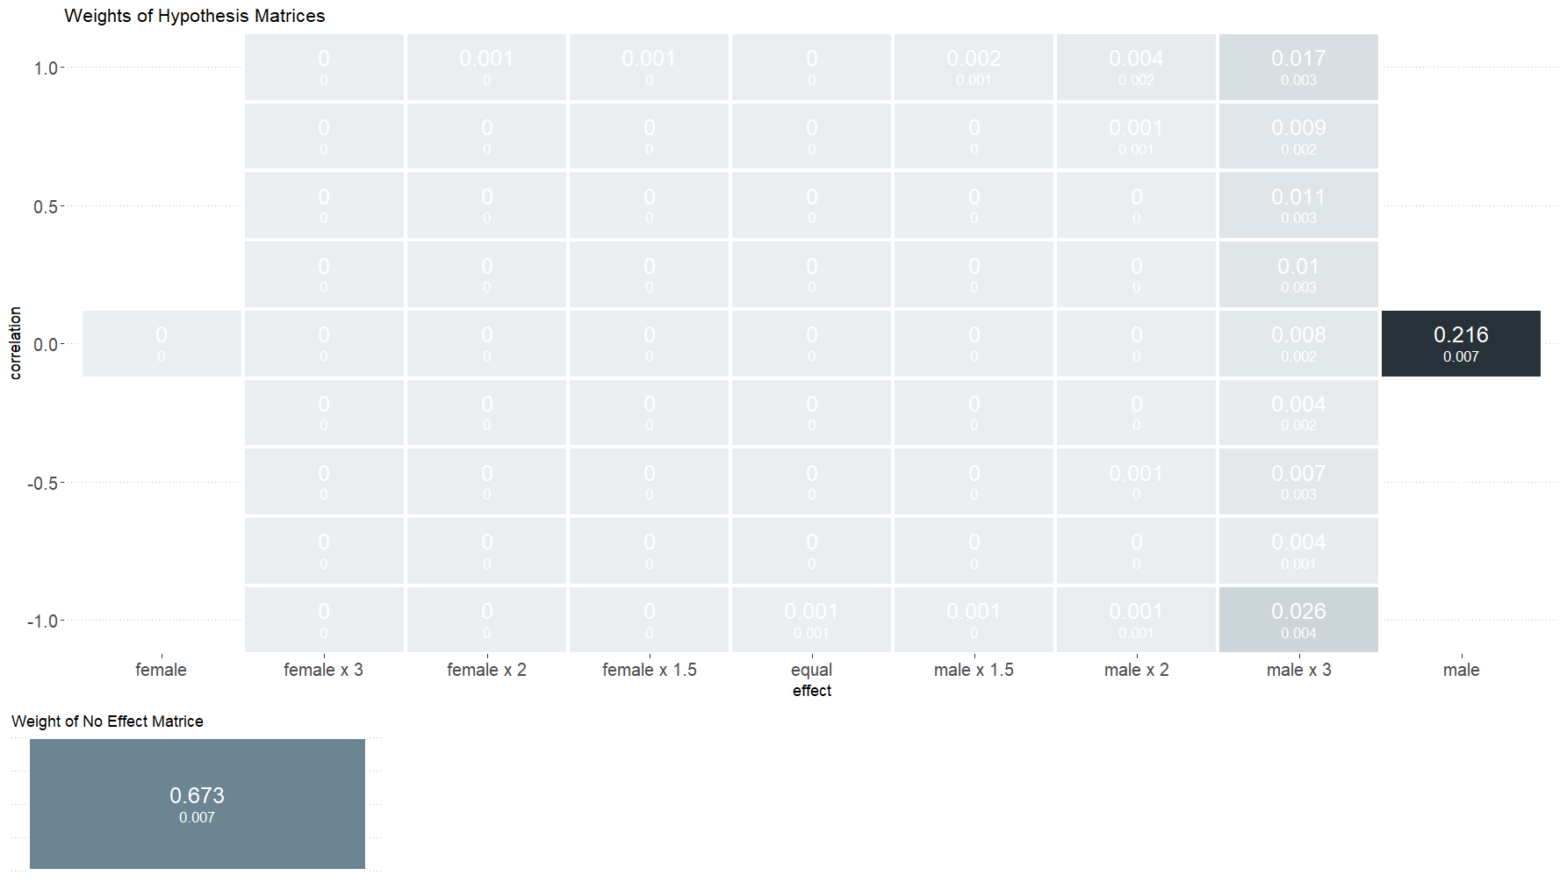

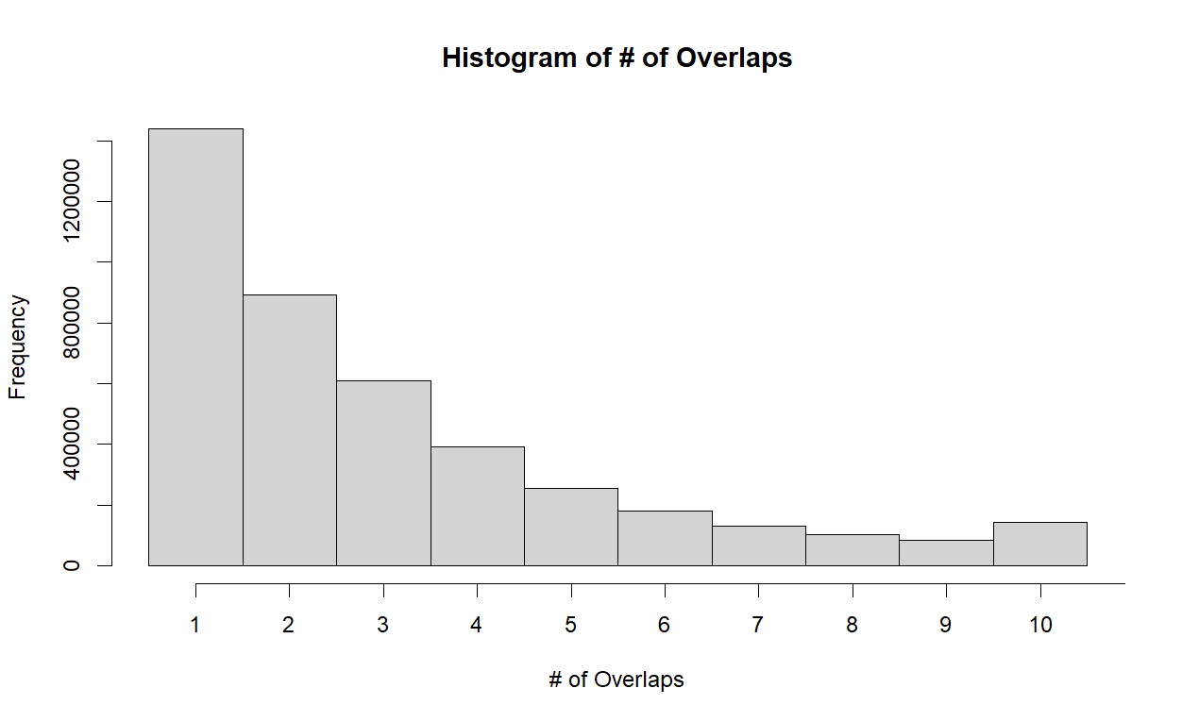

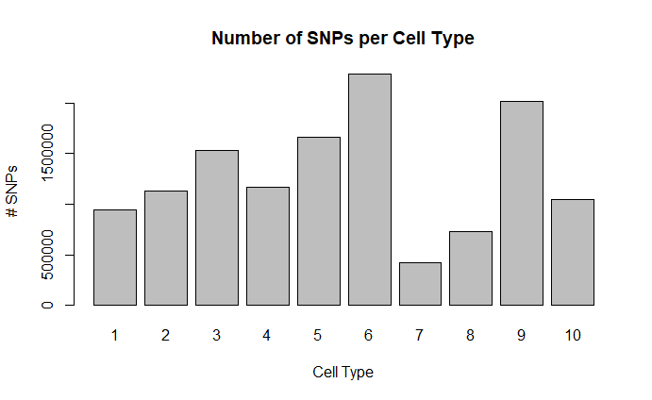

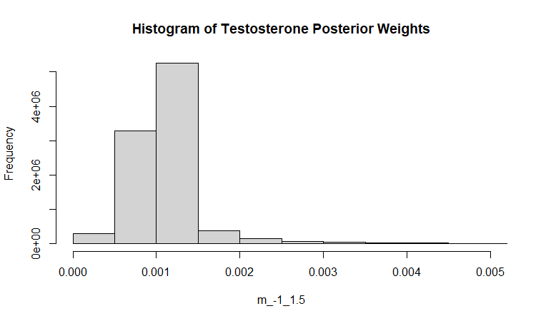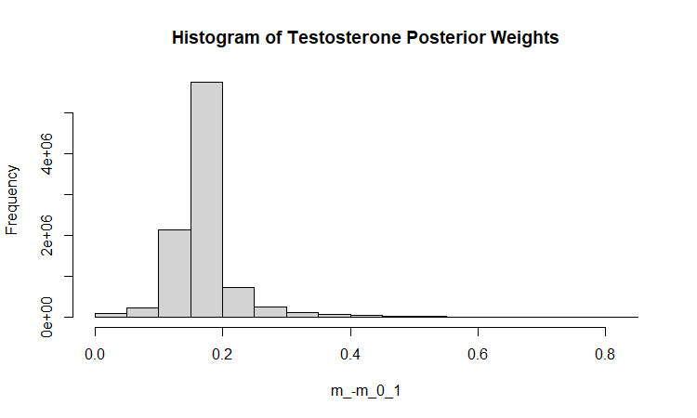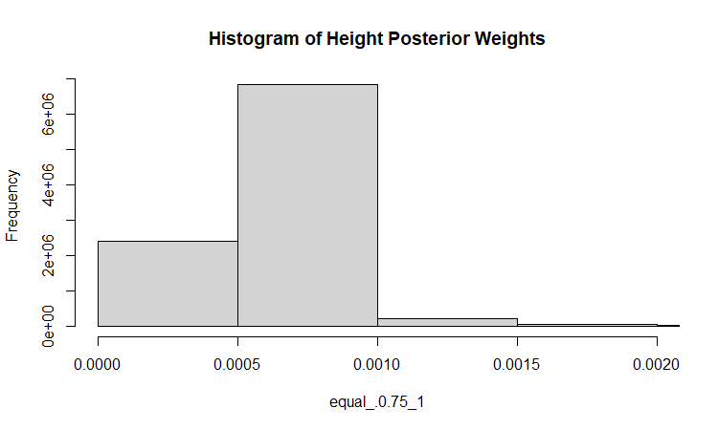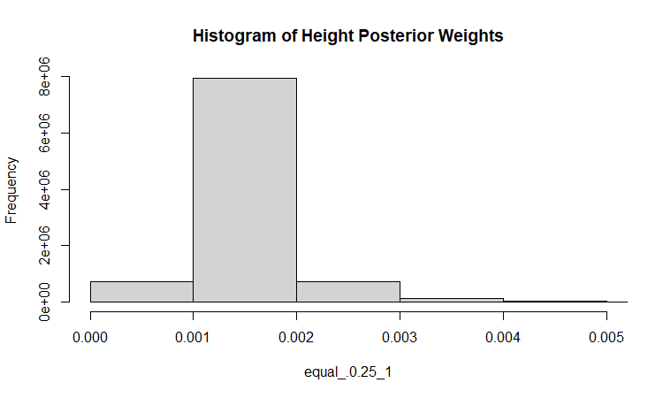

**Genetic v Environmental Variance**

Bootstrap

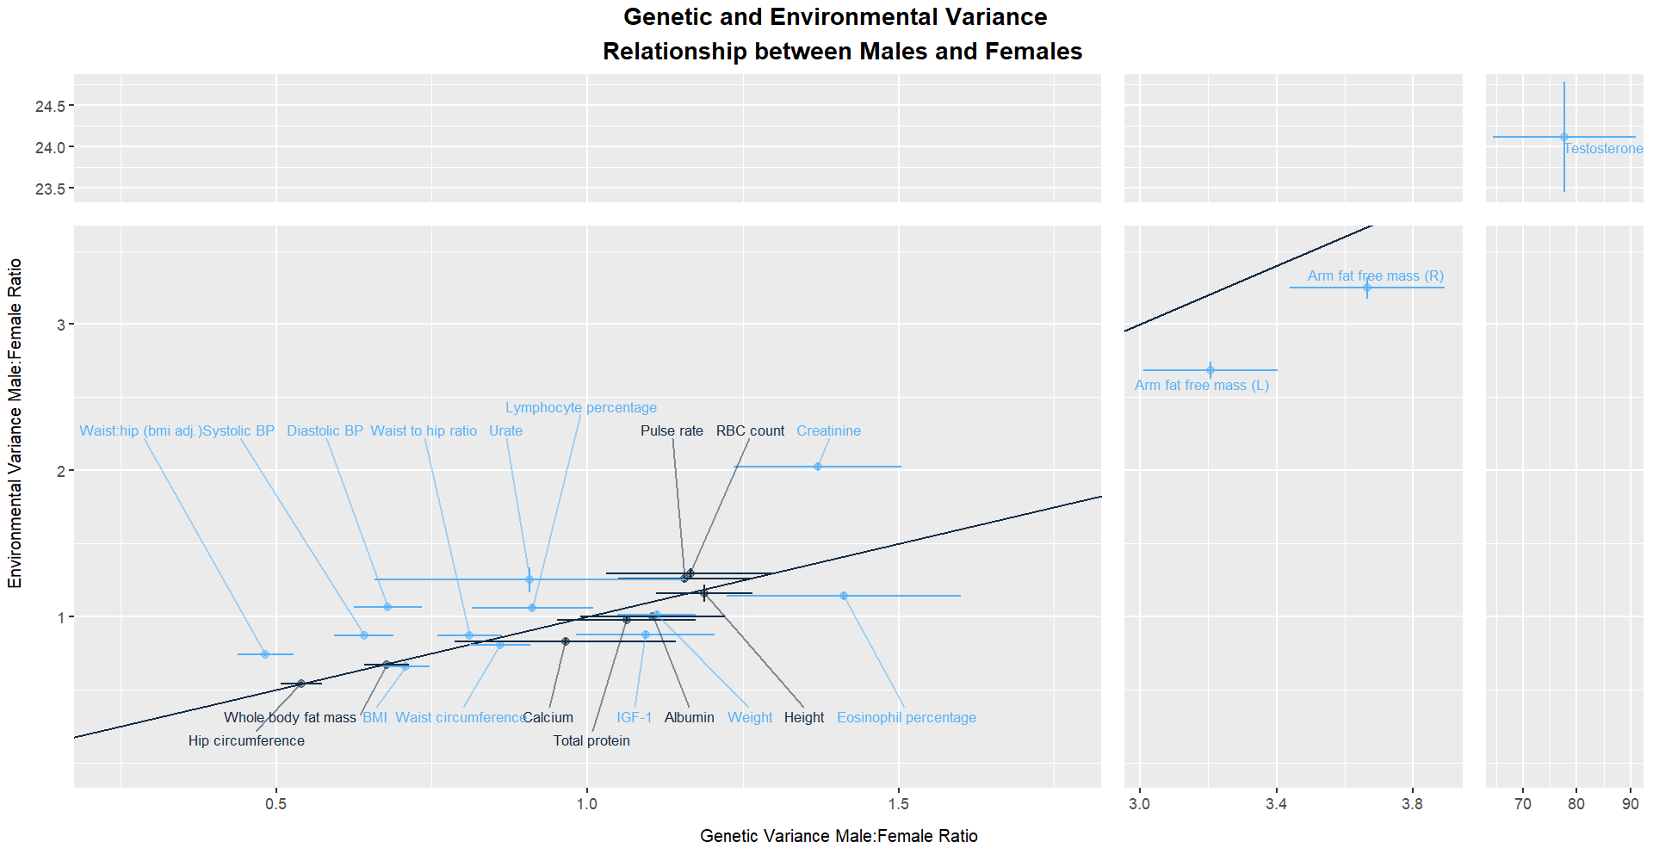

Non-bootstrap

* Plot errors to see difference
* Get schematic of cartoon of hypothesis to show what this is testing
* Illustrator – got the purchase
  + Do most in R, fine tuning in illustrator

Creatinine

* Waste product of muscles; filtered out by kidneys; exits in urine
* Serum kidney influenced by glomerular filtration rate, age, gender, skin color, ethnicity, illnesses, diet, etc
* CKD chronic kidney disease has strong genetic component
* Males, on average, have ~17% higher creatinine levels than females do
  + Reflect lean muscle mass
* Levels highly affected by dietary intake and muscle mass
* Usually measured to test how well kidneys are filtering, but known to vary with multiple factors across individuals
  + Filters at relatively steady rate within individual

Story that works for creatinine, but doesn’t say the same for other related traits

Arm -fatfree mass also not on 1:1 line

Are genetic effects and environmental effects being amplified in the same pathway???

<https://labs.selfdecode.com/blog/creatinine/>

Simulation

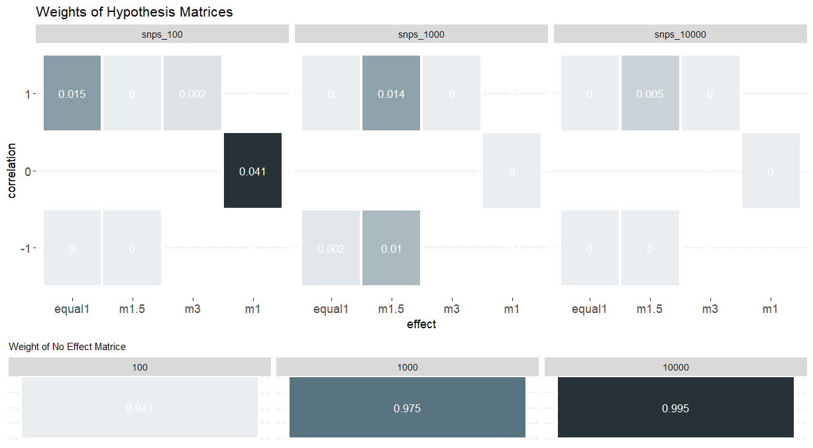

* Increasing null value when increase number of snps? Should be opposite
* As increase # snps, also decrease heritability per snp
  + On average, less heritability can infer snp as null
* Another analysis
  + Change number of snps, but keep heritability the same
* Do multiple heritability per snp – 0.05, etc

**Figure outline**

* How would describe figures in the results section
* Self-explanatory figures

**Omicron can wfh**

**1/18/2022**

* Figure 1
  + Smallest font size = 8
  + Too much white space, make it more compact
  + Consistency with font sizes across figures
    - Have important text be much larger
    - Have hierarchy
  + Only need title if give useful information
  + Have overarching title to describe what you are showing
    - “Inferring polygenic covariance structure between males and females in “testosterone””
  + Use white space for male and female label in miami plot
  + Don’t use orange for the annotations since it seems to link odd colored chromosomes
  + White font white box is eligible – maybe change entire palette or font color
  + Magnitude on x-axis
    - Bc effect size is linked to beta
  + If have room afterwards, have another covariance matrice explained
    - Don’t have arrow or have in other direction
    - Have dotted line
  + Perhaps when pointing to small heatmap, have funnel with dotted lines of both edges
  + For matrices – labels (“male-specific”, “female-specific”
  + No effect matrix
  + 2.25 matrix, confusing, maybe write out (0.75 x 3), instead of 9, write (3^2)
    - Or maybe written out in caption
* Figure 2
  + Change title to something more helpful
  + Genetic Correlation on y-axis; SNP Heritability relative to heritability of both-sex sample on x-axis
  + Arm fat free, weight, bmi; waist circ, whole body, sex specific heritability is sig higher than both-sex heritability
    - Highlight in figure text
    - Maybe add little asterisk next to those traits
  + Have larger legend in the empty space of the graph
    - Can have just the text be in color in the legend, can possible even link to one of the data points
* Missing figure?
  + Main takeaway – non-trivial correlation 🡪 mash shows difference in magnitude
  + Have figure showing across traits
    - Scatterplot
      * One axis show amplification signal (amplification M>F)
    - Overall weight on non-trivial correlation and magnitude differences
      * Trivial – perfect correlation, equal magnitude
      * Weight – proportion of traits ex. (1-(marginal weight on perfect correlation perfect magnitude))
    - People often analyze in variant specific way and miss signal, or look at genetic correlation and still may miss differences --- show up in mash as amplification signal

**FIGURE 1: Manhattan mash**

Large mash: 5 x 8 -> 4.5x6.5

Small mash: 3 x 5

**FIGURE 2: r2 by relative h2**

Dimensions: 8 x 7

**Pheno_var_mash**

Dimensions: 5 x 7

**Gene env bootstrap**

Dimensions: 5 x 7

**Pheno PGS Testosterone**

Dimensions: 6 x 4.5

Mini dimensions: 3 x 4

**PGS Comparison Plot**

Dimensions 7x4

ABSTRACT

PRESENTATION:

* Prepare outline of your results
* Paragraph for each of your results. Key points, encourage discussion
* Mainly focus on our hypothesis (mash pipeline) and main results
* Have the figures be clear in what we did
* Share draft of presentation – can be bullet points

CONFERENCES:

Check exact deadlines

BOG

* Need to pay for application
* They manage your accommodation
* The gala event of the year, emphasis on human genetics
* Oral presentation chances are slim

PEPG

* Check if need to pay and completely register when applying
* Both population and statistical genetics
* Better chances for oral presentation

Send it to him today:

Abstract

* These conferences mainly focus on biology
* Base yours off of previous papers
* Max 2 sentences of setting up importance of problem, the gap in understanding
* Middle – results conveyed in interesting way
  + What we did – differently, interesting
    - Don’t talk about mash specifically
  + Give numbers and descriptions of concrete results that are new
  + Your innovations
* Final summarizes give punch line in terms of broad implication
* Our main evidence is that we see a lot of GxE, but through amplification on magnitude of effects of complex traits
  + Give some numbers to summarize

Nontrivial Weight

* See more GxE in terms of magnitude, not correlation
* Y axis: (1 – perfect correlation)
* (1 – weight on equal effects) : for x axis, also a proportion
* Version on figure: close to 1:1, and close to perfect correlation

Reshare github

Corral

* Can move anything there
* Can double check with Jared verify that I can put ukbb files on corral (not have to be corral-protected)

Figure::

Heritability diff v amplification diff

FIGURE 5

* Additive genetic effect for each sex’s phenotype value
  + Genetic effect and environmental effect
  + Depend on genotype and effect sizes
* What allele person gets on their autosome is independent of sex
  + Distribution of genotypes is independent of sex
* Our paper argues that effect size is different, largely through amplification between sexes
* How does this GxS amplification happen
* Ex. Pathway that affects female trait amplified by a constant
  + See if the amplification is the in the same way for environmental effect
  + Y = G + E 1:1 line
* If away from 1:1 line, the amplification is different in genetic or environmental effect
* Is this consistent with the null model of no amplification
* Environment may no be randomly distributed
* Simple model is consistent with half of the traits we are looking at
* We can make it 4 SE for error bars

Abstract

* Try to add the environment / genetics result
* Title: grammar is weird
  + Title should tell you what the most important result: should make assertion

PRESENTATION

Previous Studies

* For sex specific snps, can test for interactions at level of individual snps
  + Results have been underwhelming, don’t often find big effects
  + Switch over to think of it in more polygenic way
* Switch order so SNPs are first
* Correlation only one part of story

Add purpose slide before or after slide 2

* Say more about motivation of study – talk about sexual dimorphism in humans, why it is important for health
* Vast majority of genetic effects coming from autosomes
  + Most people think of sex chromosomes, but most heritability from autosomes
* Complex traits, polygenic. Was thinking a lot about GxE for complex traits
  + Can develop methodology for other organisms (randomize environment)
    - Gxe is rule for other organisms, in humans its hard to define and underwhelming research
    - Problems with reverse causality – is phenotype affect environment or environment affect phenotype --- doesn’t really exist in sex
    - Sex minimizes other biases – population structure (independent of sex), reverse causality, independent of genetic frequency, recruitment bias
  + If want to think about it with humans, large scale; sex is a good place to start
    - Not heavy recruitment bias with sex in ukbb and random segregation of genotype
* Using UKBB data

Covariance of Genetic Effects

* Change creatinine to a true null model or clear one-sided amplification

Testosterone as an underlier

* For some trait such as whole body fat mass, there is strong relationship
* Clear relationship but, different between males and females
  + Cannot look at it as continuous variable

Add genetic and environmental variance effect graph somewhere

Backup slides

* Pipeline figure, PGS
* Make one for mash

INTRODUCTION

* Motivation, background, sexual dimorphism
* Underwhelming evidence for GxE
* Last paragraph is like the thesis, summary of what’s about the study
  + We did this, we found this
* Have signposting throughout the text, to mark readers where they are at
* Past tense

RESULTS

* Figure and results appear together
* Each section has a mini story, so clear what the motivation is to do next and how the analysis was done
* When describe results – what you see across traits, and give numbers and confidence intervals, statistical support and proof
* First write outline of paragraphs and what’s in the paragraphs – share with Arbel
* Can first describe most important result or overall before diving into other interesting results

Gen corr

* Correlated high, but diff in magnitude Segway

Mash

* Only using hypothesis matrices – span what we want to interpret
* Data driven corresponded to predefined matrice
* Show the plot one by one, first matrices, then big matrices – explain distribution of matrices
* Add plus minus sign in front of SE
* In the small map, keep male/female in same location, just change sign

Pgs testosterone

* Switch male female

PEQG – arrange flights and lodging

BOG – includes board, we need to find flights, cali in summer

**2/15/2022**

* Language needs to be precise
  + Some need more quantitative descriptions – some sentences incorrect in concept
* Correlation not just about opposite signs
  + Different variants are contributing – identity of causal variants (tag snps)
  + Ex. Testosterone have diff pathways, diff mechanisms 🡪 diff variants in diff locations
* Magnitude differences can also lead to imperfect correlation
  + Distinguish between magnitude differences (systematic diff affect large set of variants in same way) and snp identity and direction (correlation)
* Higher heritabilities in single sex heritability not only because opposite signs, research more why
  + Suggest it but also mention we don’t have much evidence for it --- not in bernabau, Armstrong, or Flynn
    - One possible explanation, but we have evidence in mash showing that large proportion do not show negatively correlated effects
      * Plot with relative h2; male and female;; genetic correlation and mash correlation
  + Could also do own analysis – look at all snps below lfsr of 0.05, see how many are sign concordant
  + Y_m = G_m + E_m
    - Variance ignoring sex is larger ??
* When get to mash part, revisit the higher sex-specific heritability
* Most traits are compatible with model for same amplification – write part with the math model in results
* Not proving anything, just that results are consistent with the model
* Have good biological example
  + Genomic regulator of body fat –environmental effect, ex sex hormone or epigenetic influence (from sex) amplification is the same
  + Share pathway (pathways merge) between genetic and environmental affect – that pathway is amplified – therefore same amplification between genetic and environmental effect
  + Not 1:1 affecting the regulator in independent pathway, not same amplification for male/female
  + Can have cartoon next to example
    - Genetic regulation 🡪 [core gene affecting BMI] 🡪 [Effect size of core gene modulated by T level] 🡪 BMI
    - [ Maternal epigenetic effect on fetus ] 🡪 [core gene affecting BMI] ----
* Refresh on paper Tom sent
  + Heritability
  + Amplification model
* Squashing variance vs interpretating variance
* Global analysis of (fit unstructured model for genetic and environmental variance)
* Biological interpretation
* Clearly explain mash; what’s your hypothesis